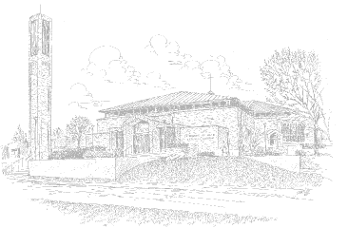

DATE:

To Whom It May Concern:

St. Francis of Assisi Catholic Church is seeking a gift donation of ________ empty paper grocery bags (with handles if possible).

Your 100% tax-deductible gift donation, of empty paper grocery bags, will be used for a food/grocery program to help meet the needs of many people in poverty.

Our Tax Exempt Number is: 38-1404594.

We distribute the empty bags to our parish members, and, send them out shopping. The bags are returned full of groceries purchased by parish members and then donated & delivered to the needy.

Learn more about this food/grocery drive at:
www.stfrancisa2.com/socialministry/fooddrives.htm

Thank you for your consideration.

Sincerely,

St. Francis Parish Social Ministry
734-821-2121 <swright@rc.net>
www.stfrancisa2.com/socialministry/

